## Customer Default Identification Report for Credit

## Assn 5 Task 3

## Celeste Hofer

**Problem:**

An increase in customer default rates is bad for Credit One. Credit One provides recommendations to its business partners regarding which customers should be approved for loans. Credit One uses historical data to determine which potential customers are a good credit risk. Recently, more of the individuals recommended to be good credit risks have been defaulting on loans—this is harmful to Credit One’s business. Credit One needs to improve the accuracy of their recommendations of which potential customers are good credit risks, or Credit One risks losing both business and credibility.

**Goal:**

Examine current data to develop an approach to determine which potential new customers are likely to default on payment of loans. This is very high priority as it impacts revenue for both Credit One and our business partners.

Questions We Investigated:

1. Can we approve customers with high certainty?

Credit One is able to look at existing data and develop highly accurate models indicating who should be approved for loans. The overall accuracy of our top model is 85%.

* 1. Credit one has high confidence in our ability to determine who will not default on loans. We have 85% confidence in the precision with which we measure who will not default on loans.
  2. We have slightly less confidence, 67%, in the precision of our prediction on who will default on loans.

Our current prediction, based on existing data, is displayed below. The majority of customer are predicted to not default; we have high confidence in the precision of stating who will not default. Efforts need to be focused on predicting who will default.

**Default Likelihood**

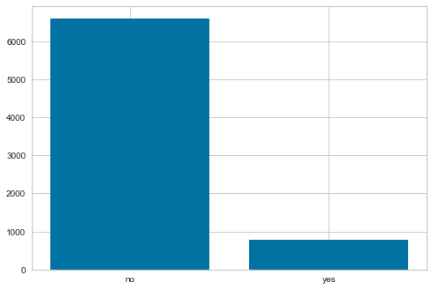

1. What data attributes are statistically significant to the customer loan default issue?

Not all models that we examined provided the attribute importance. However, one of our top models did, this is a graph of the features or attributes deemed most important in predicting default.

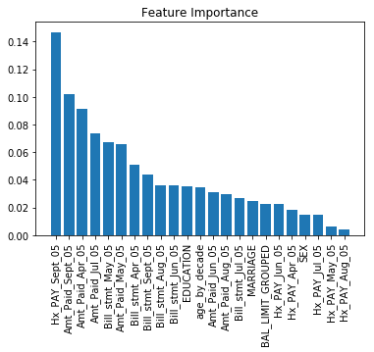

Our analysis shows that the most important attribute that predicts loan default is the history of past payment for the month of September 2005. This is the most recent month available for information on payment history. This attribute includes information on payment delays, use of revolving credit, on time payment, and no activity.

When we look at default, we see that the use of revolving credit, a one-month payment delay, and a 2-month payment delay are indicators of default. However, those who do not default on loans also use revolving credit.

Demographic attributes are not high on the list of predicting default. However, of these demographics, age grouped by decade and education are the most important. We plotted the likelihood of default based on educational level and age group. Note that customers in their 20s and 30s who have attended either a university or graduate school are more likely to default. However, individuals with those same demographics are even more likely to NOT default. Thus, we can’t really conclude anything based n demographics alone based on our current data.

Other data attributes that were also found to have high importance in predicting default were amounts paid per month and billing statements per month.

1. What proven methods can we use to discover other information that may be helpful?

It is very important for Credit One to keep updating their data and re running our models in order to keep improving our accuracy of prediction. As we add more data for our models to train on, the accuracy of our predictions on default likelihood should only increase. We recommend re running our models every month ideally as new monthly data comes in. If that cannot be accomplished, quarterly updates must occur. However, we recommend monthly updates.

Credit One also needs to consider if other types of data is available to be collected, which may help improve our predictive models.

1. How does Credit One verify that customers can/will pay their loans?

Credit One is only able to look at the likelihood that customers will repay loans based on the current data we have on customer demographics, billing statement amounts, payment history, existing default information, etc. The company will do its utmost best to provide accurate information on who is a credit risk, based on the data that we have. Additionally, Credit One will continue to update our customer data (add in any new data) in order to provide accurate predictions of whether new customers will default on loans.

Please keep in mind that there is no crystal ball approach that will tell which customers may fall on hard times in the future and default on loans. Illness, loss of employment, natural disasters, etc.—a multitude of events which cannot be foretold may impact the ability of an individual to pay their bills.

A business may take the approach of determining how important the individual loan repayment is to the customer’s general well-being ( housing, transportation bills), but how an individual customer may rank the importance of the service or product is still variable between individuals. There are many subjective factors that influence bill payment.